Name : Aditya Adinath Kirtane , Roll No.26

Division:D15C

Experiment No.9

**Aim**: To Understand Continuous monitoring and Installation and configuration of Nagios Core, Nagios Plugins and NRPE (Nagios Remote Plugin Executor) on Linux Machine.

**What is Nagios?**

Nagios is an open-source software for continuous monitoring of systems, networks, and infrastructures. It runs plugins stored on a server that is connected with a host or another server on your network or the Internet. In case of any failure, Nagios alerts about the issues so that the technical team can perform the recovery process immediately. Nagios is used for continuous monitoring of systems, applications, service and business processes in a DevOps culture

Step 1:Create amazon linux Ec2 instance

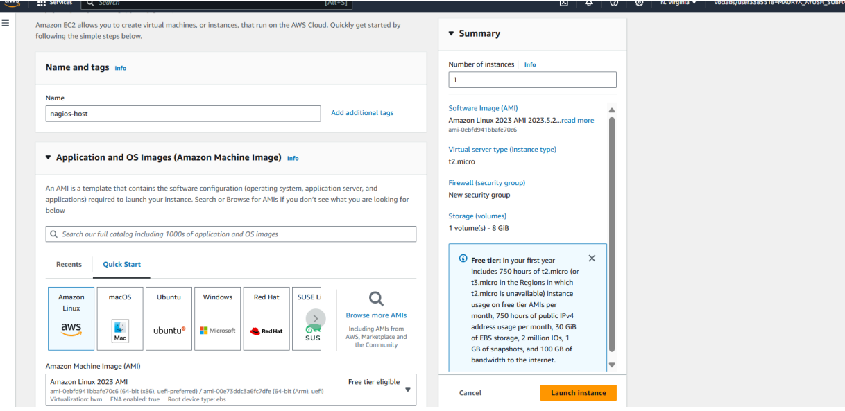

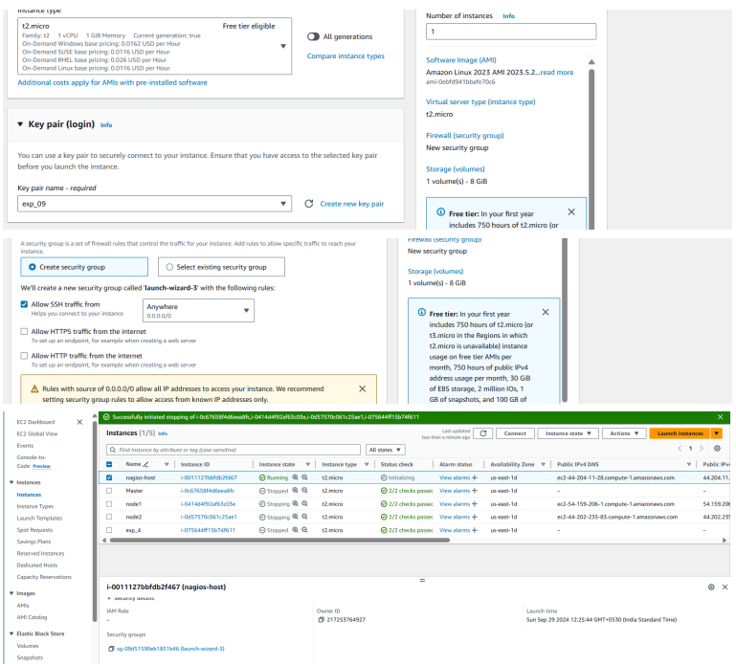

2.under security group make sure Http,Https,ssh,ICMP Open from everywhere.

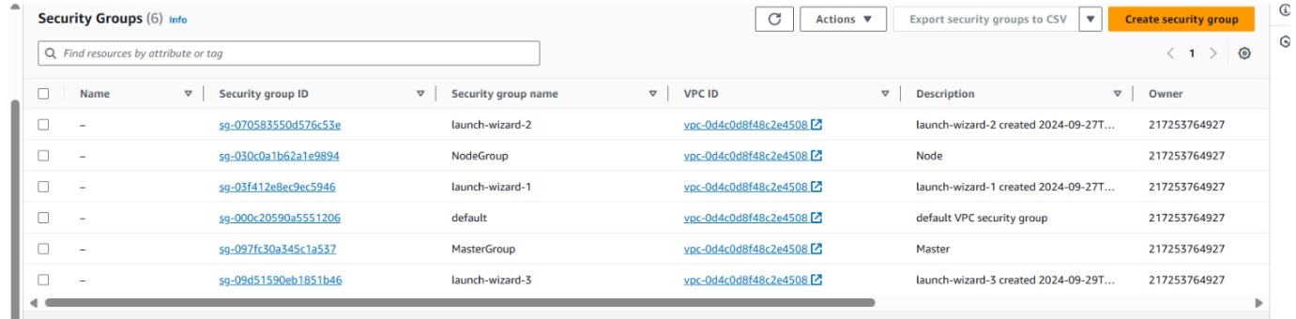

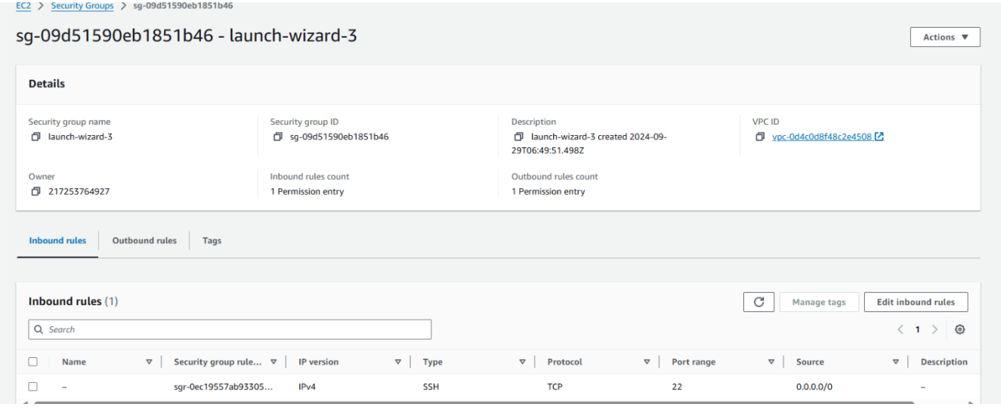

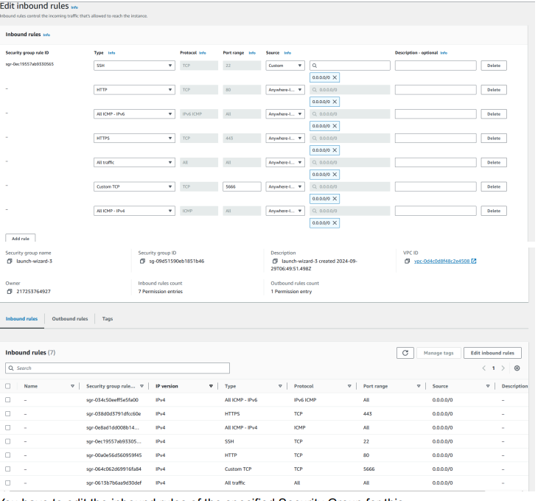

3.Connect with Ec2 instance or simply use Ec2 instance to connect from browser.

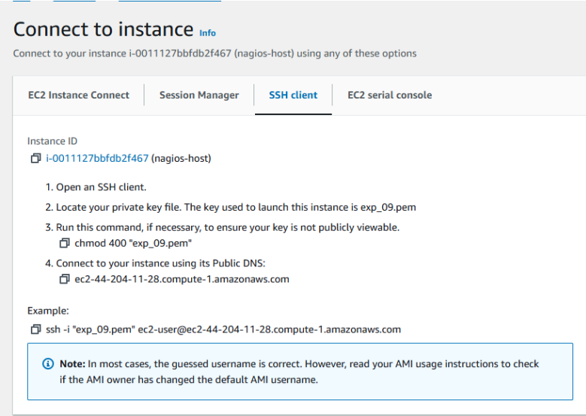

4.open command prompt and paste ssh command

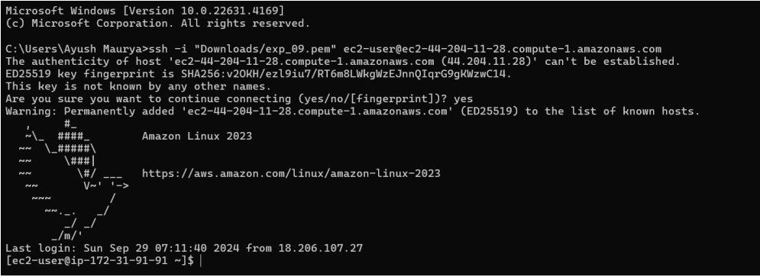

5.sudo yum update.

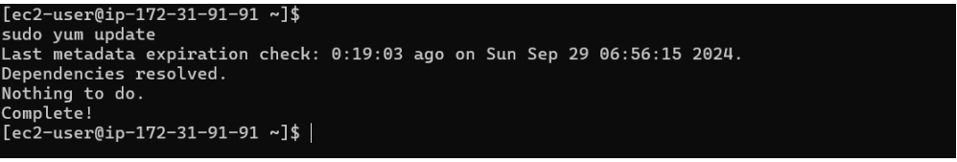

6.sudo http install httpd php

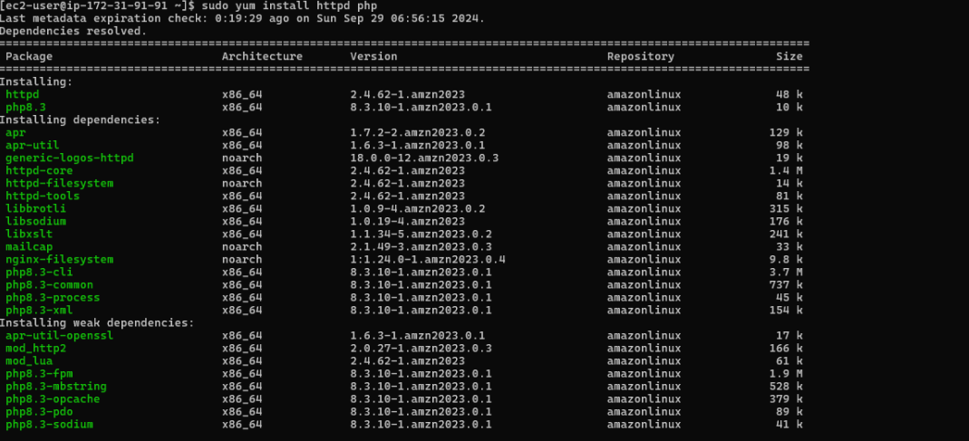

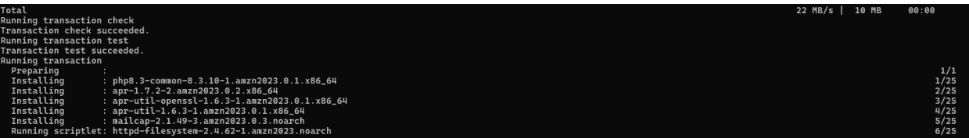

Sudo yum install gcc glibc-common

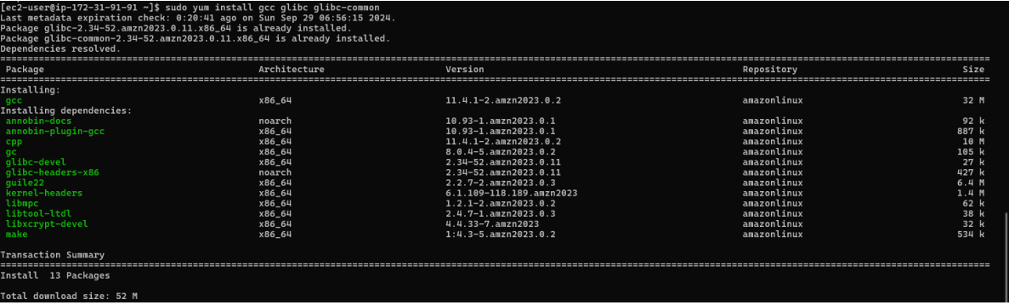



Sudo yum install gd gd-level

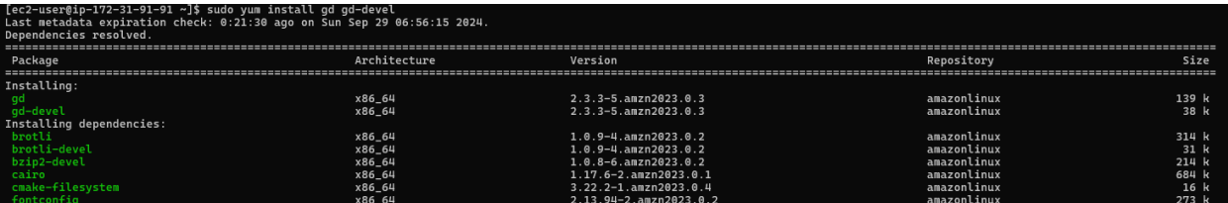

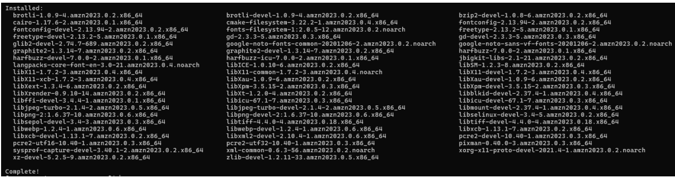

5.create a new nagios user with password.

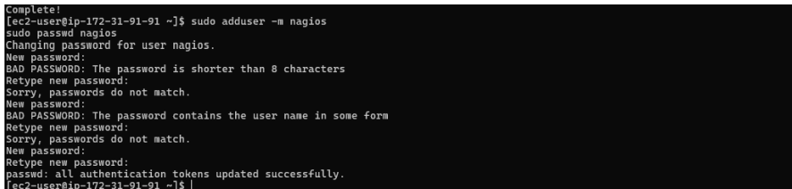

6.create a new user group

Sudo groupadd nagcmd



7.use three command so you don’t have to use cd



8.create a new directory



9.Use wget to download the source zip files.

wget https://assets.nagios.com/downloads/nagioscore/releases/nagios-4.5.5.tar.gz

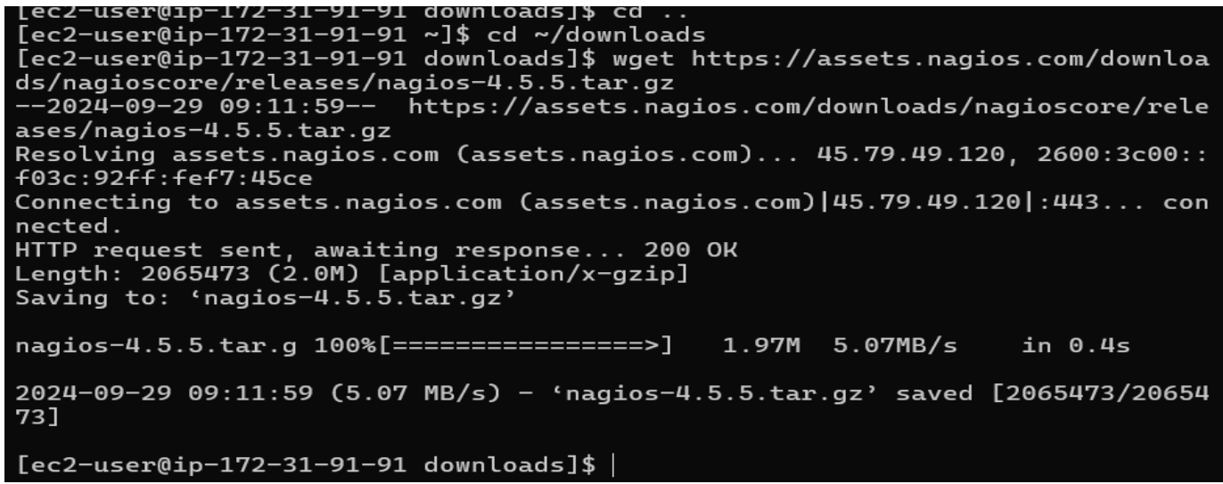

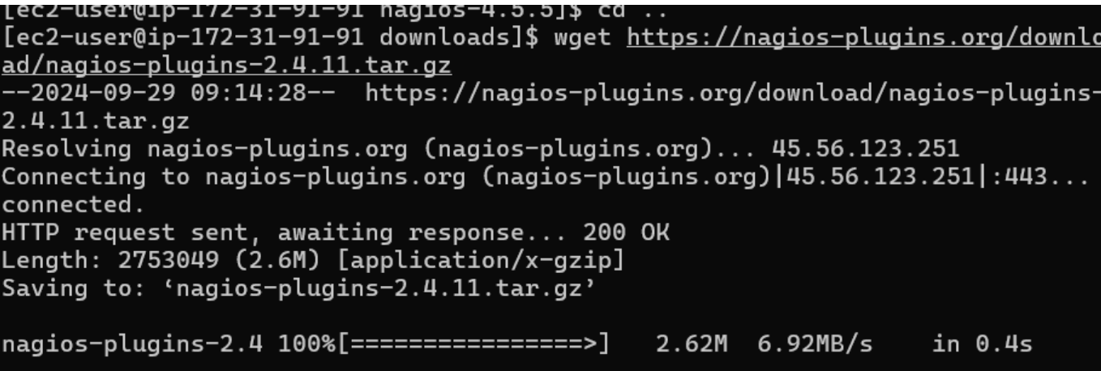

10.use tar and unzip to change to directory

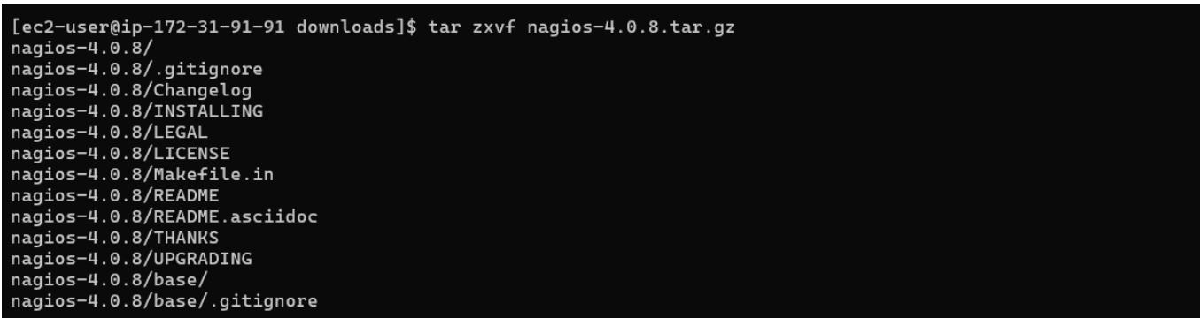

11 . Run the configuration script with the same group name you previously created. ./configure --with-command-group=nagcmd



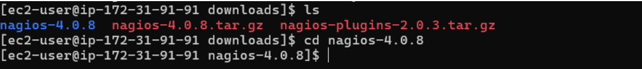

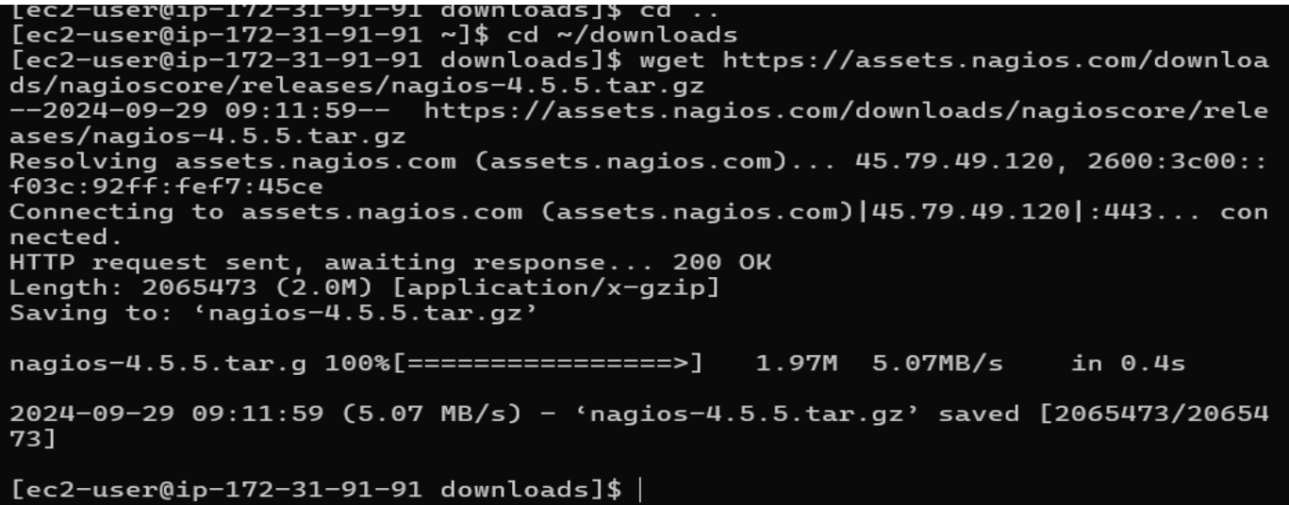

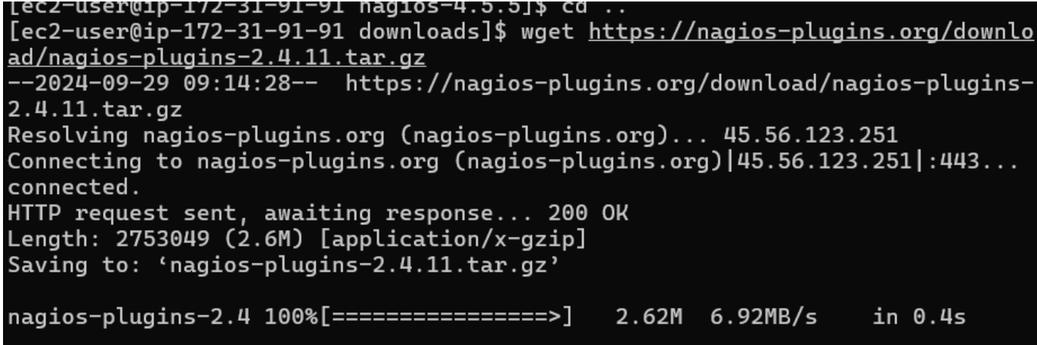

10.use tar to unzip and changes to directory

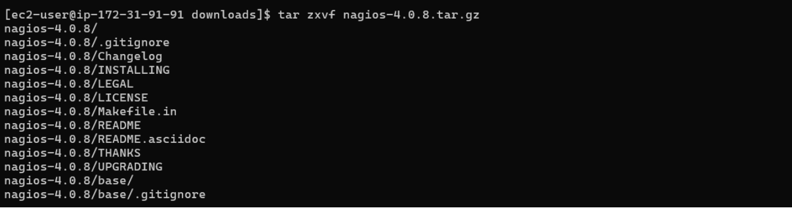

11.Run the configuration script with same group.



12.sudo apt install openssl-devel

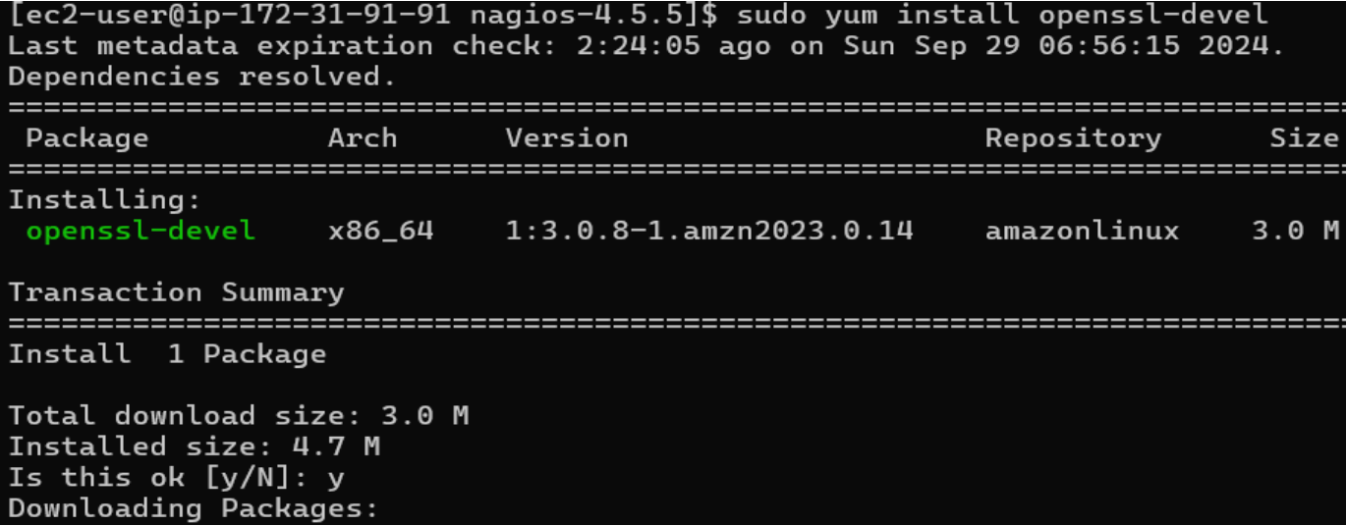

13.npm run.

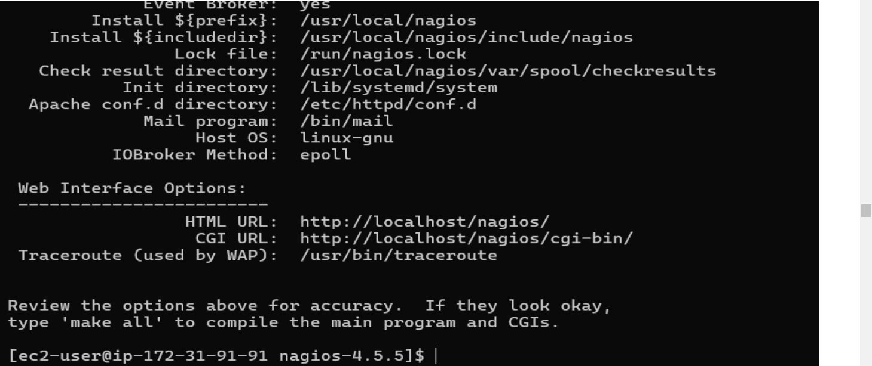

14.Complete the source code

Make all

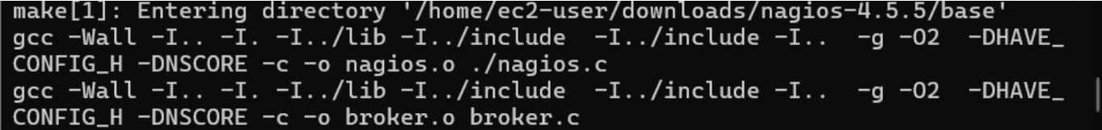

15.install binary,init script,sample binary files

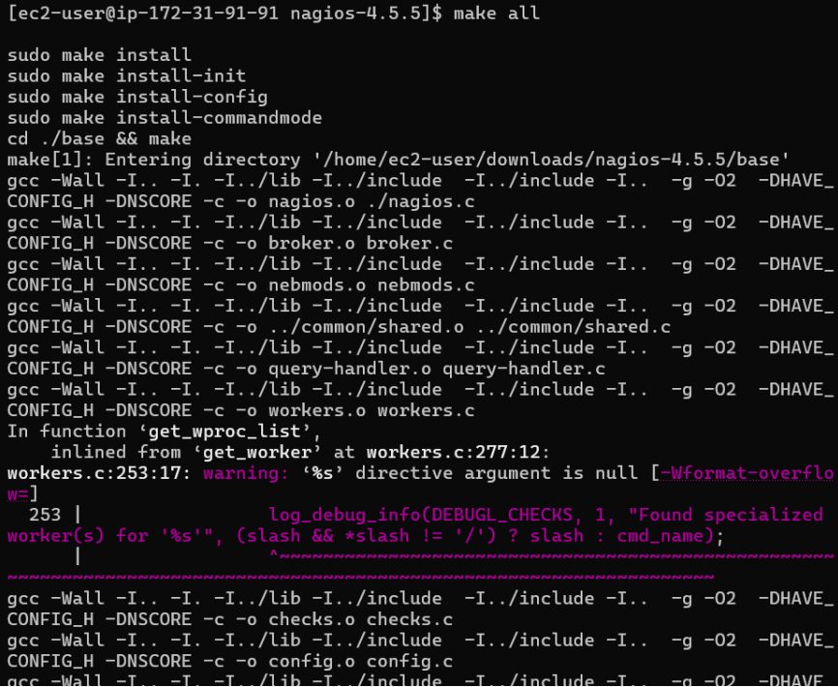

14. Edit the config file and change the email address. sudo nano /usr/local/nagios/etc/objects/contacts.cfg

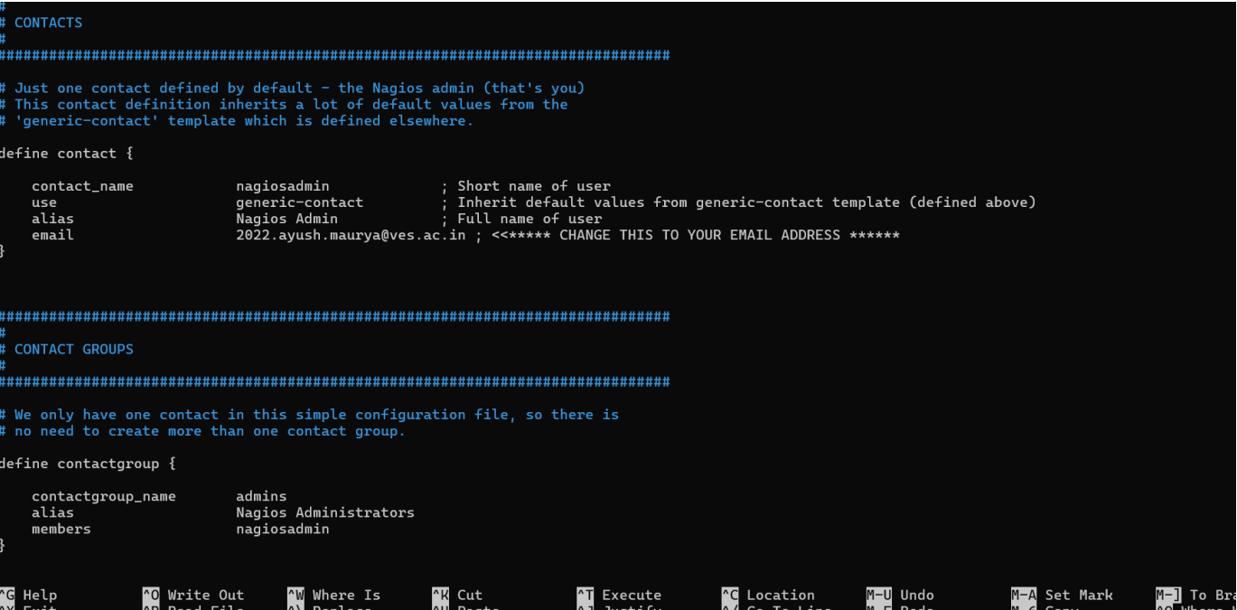

15.configure web interface.

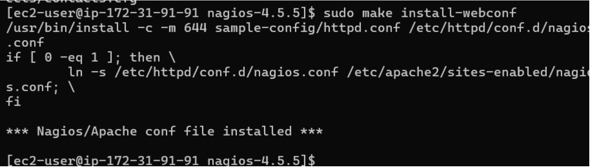

16.create nagiosadmin account for nagios login along with password.

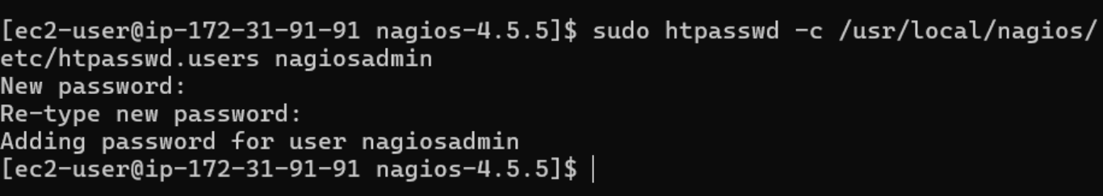

17.Restart apache.

Sudo service httpd restart

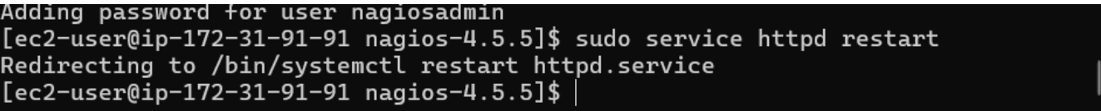

18.go abc to download folder.

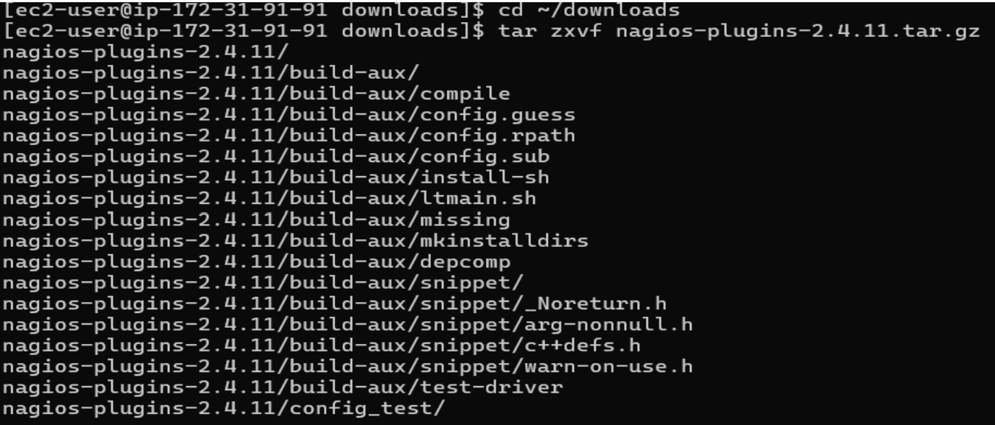

19.compike and install plugins.

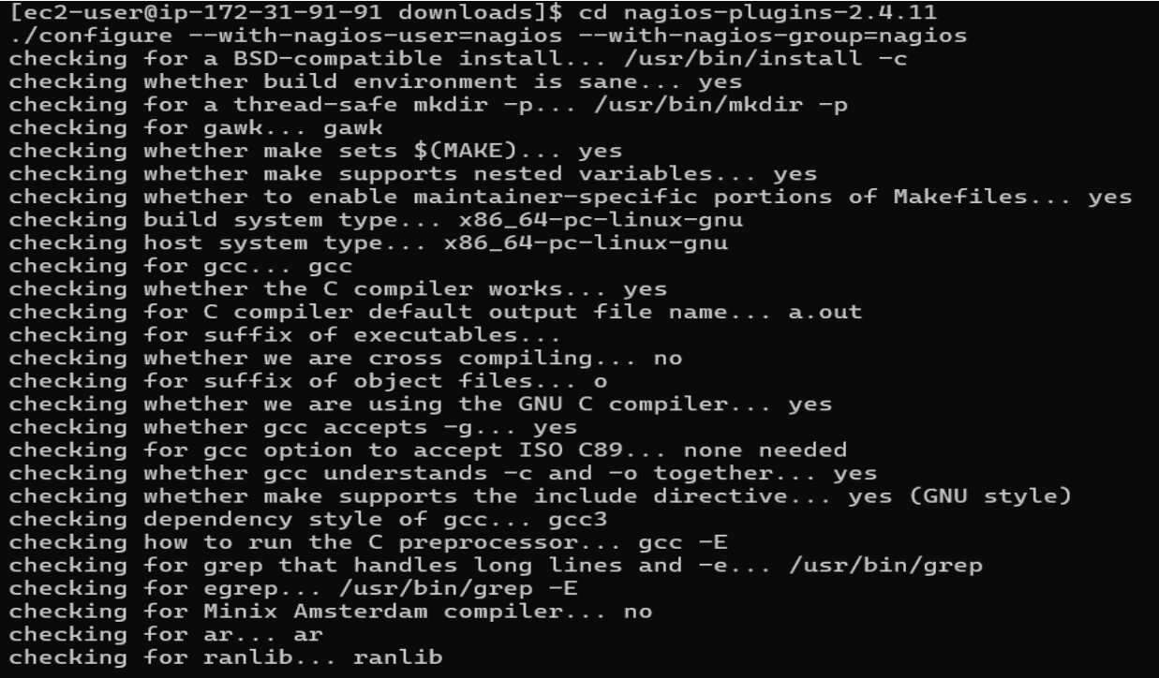

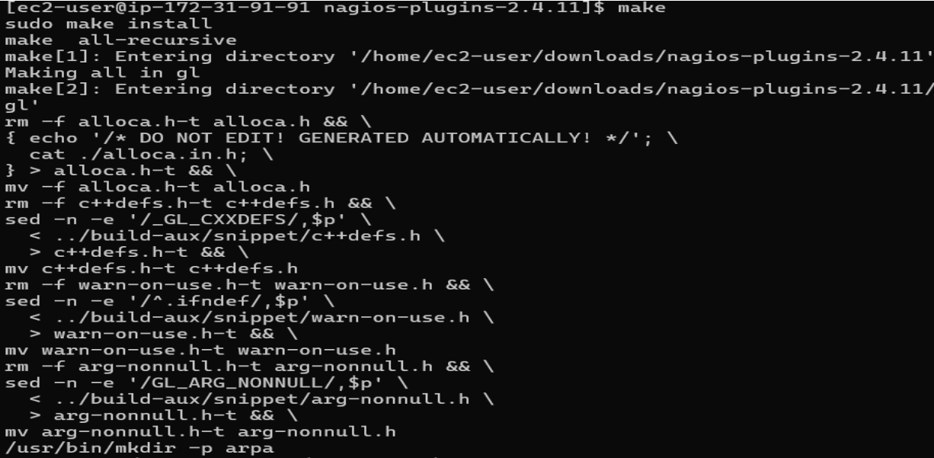

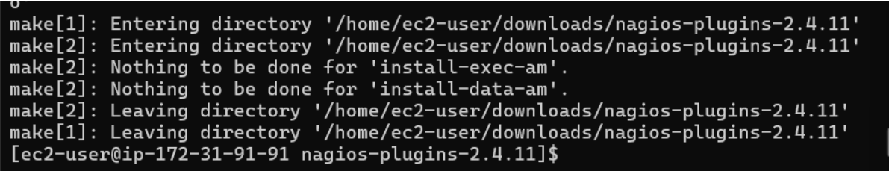

20.start nagios.

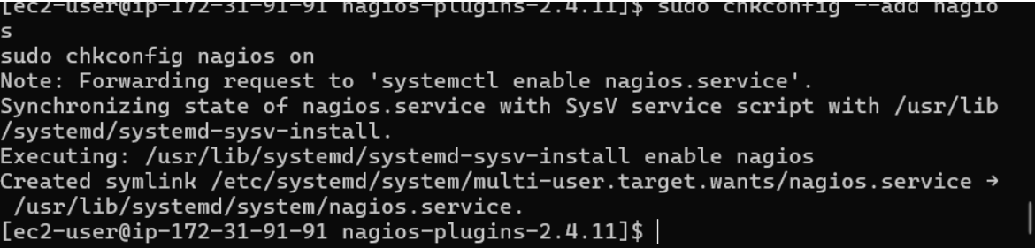

21.verify sample configuration files.

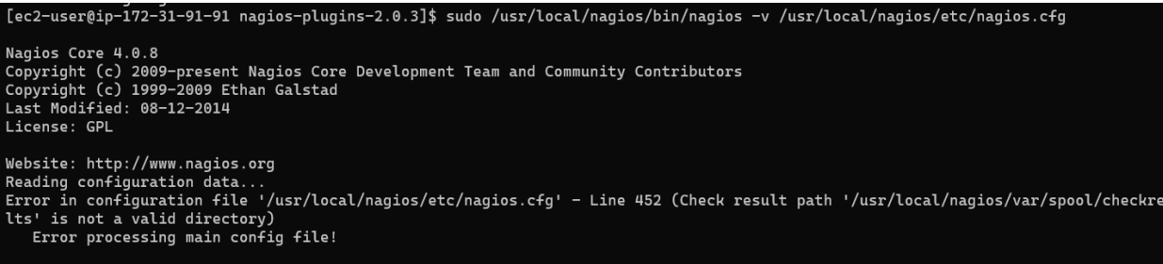

#Create a missing directory

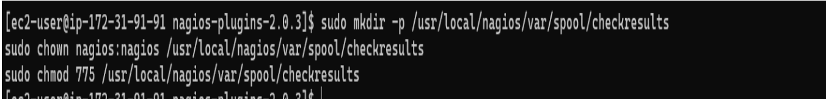

Now run again

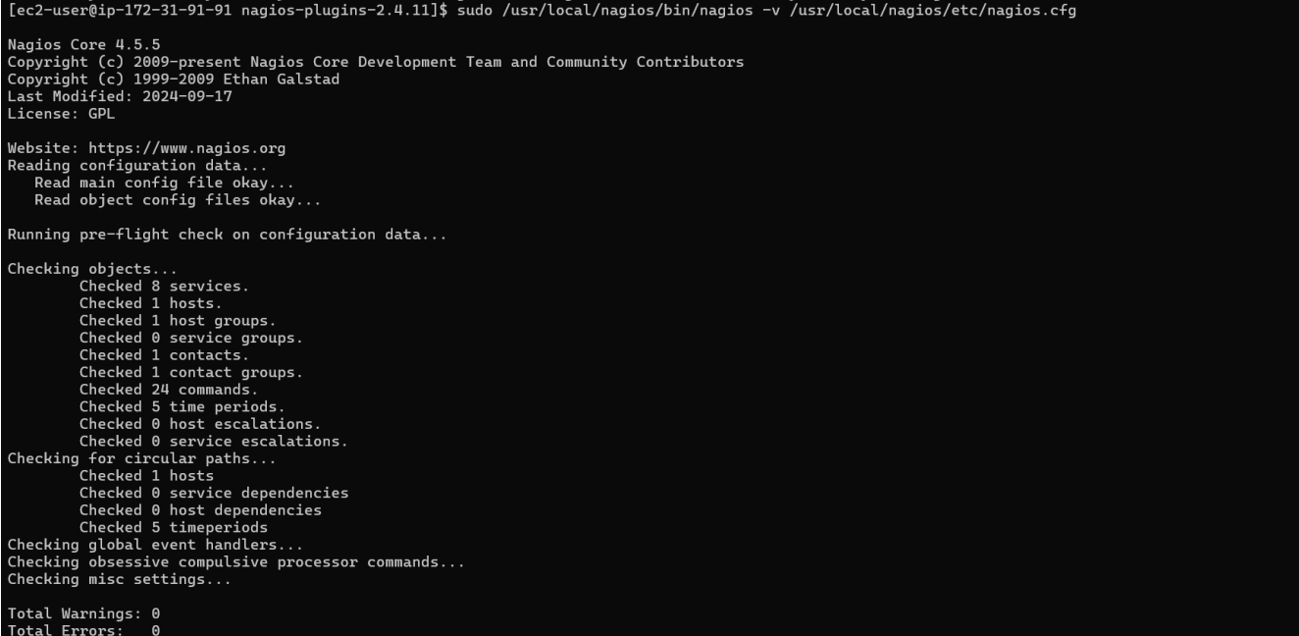

Sudo service Nagios start



Check status of nagios

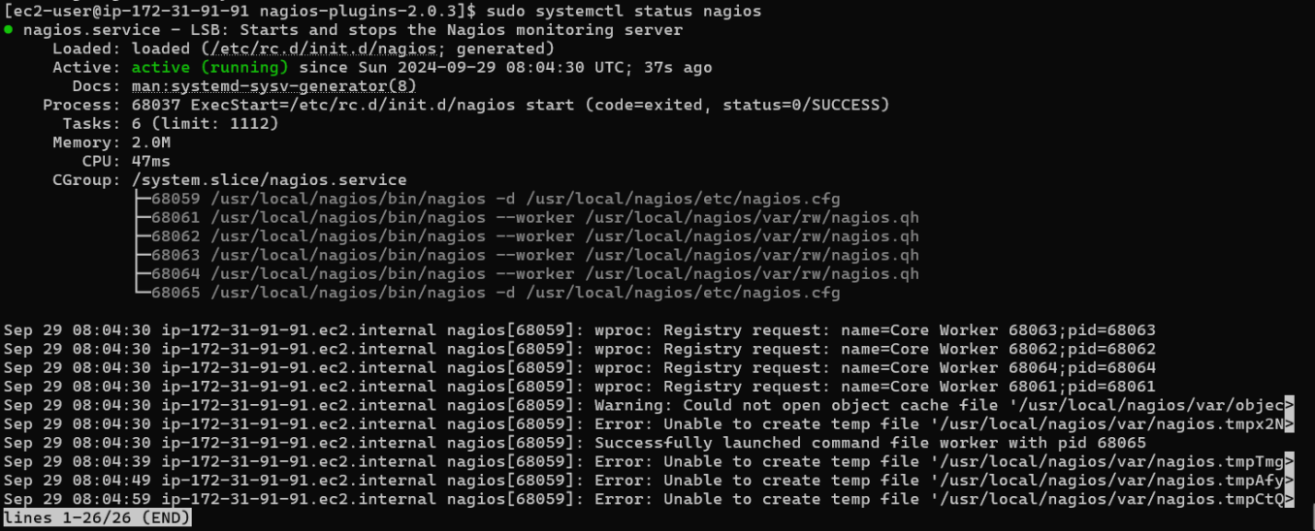

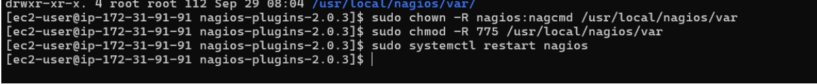

22.Go back to Ec2 console and copy public ip address

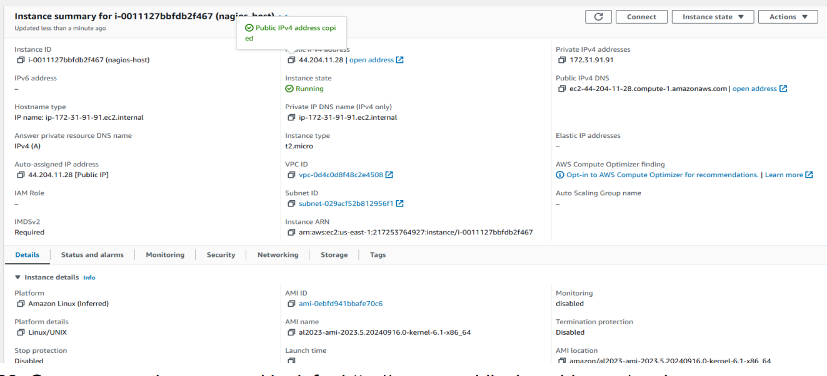

23. Open up your browser and look for http:///nagios Enter username as nagiosadmin and password which you set Step 16. 24. After entering the correct credentials, you will see this page.

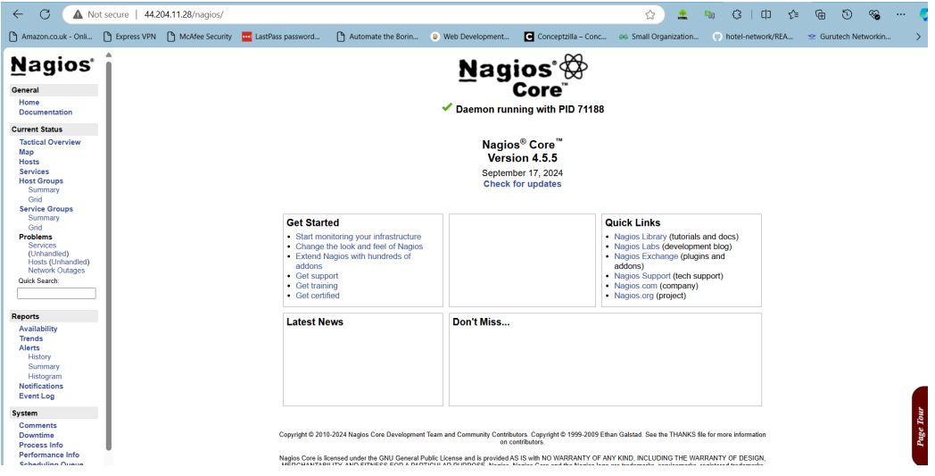

**Conclusion:** In this practical, we successfully installed and configured Nagios Core along with Nagios plugins and NRPE on an Amazon EC2 instance. We created a Nagios user, set up necessary permissions, and resolved common installation errors. Finally, we verified the setup by accessing the Nagios web interface, confirming that our monitoring system was fully operational.